

**JP COLLEGE OF ENGINEERING**

**Nalaiya Thiran**

# executed by



**Industry-specific intelligent fire management system**

# Project ID : PNT2022TMID50097

**Team Lead : Sneha K**

# Team Members : Thanalakshmi M

**Ramya R Santhiya V**

**CONTENTS**

|  |  |
| --- | --- |
| **Title** | **Page Number** |
| 1. **INTRODUCTION** |  |
| a. Project Overview | 4 |

|  |  |
| --- | --- |
| b. Purpose | 4 |
| 2. **LITERATURE SURVEY** |  |
| a. Existing problem | 5 |
| b. References | 5 |
| c. Problem Statement Deﬁnition | 6 |
| 3. **IDEATION & PROPOSED SOLUTION** |  |
| a. Empathy Map Canvas | 7 |
| b. Ideation & Brainstorming | 8 |
| c. Proposed Solution | 9 |
| d. Problem Solution ﬁt | 10 |
| 4. **REQUIREMENT ANALYSIS** |  |
| a. Functional requirement | 11 |
| b. Non-Functional requirements | 11 |
| 5. **PROJECT DESIGN** |  |
| a. Data Flow Diagrams | 13 |
| b. Solution & Technical Architecture | 14 |
| c. User Stories | 15 |
| 6. **PROJECT PLANNING & SCHEDULING** |  |

|  |  |
| --- | --- |
| a. Sprint Planning & Estimation | 15 |
| b. Sprint Delivery Schedule | 16 |
| c. Reports from JIRA | 17 |
| 7. **CODING & SOLUTIONING** |  |
| a. Feature 1 | 18 |
| b. Feature 2 | 20 |
| 8. **TESTING** |  |
| a. Test Cases | 21 |

|  |  |
| --- | --- |
| b. User Acceptance Testing | 22 |
| 9. **RESULTS** |  |
| a. Performance Metrics | 23 |
| 10.**ADVANTAGES & DISADVANTAGES** | 24 |
| 11.**CONCLUSION** | 24 |
| 12.**FUTURE SCOPE** | 24 |
| 13.**APPENDIX** |  |
| Source Code | 25 |
| GitHub & Project Demo Link | 25 |

1. **INTRODUCTION**
   1. **Project Overview**

* The smart fire management system includes a Gas sensor, Flame sensor and temperature sensors to detect any changes in the environment.
* Based on the temperature readings and if any Gases are present the exhaust fans are powered ON.
* If any flame is detected the sprinklers will be switched on automatically.Emergency alerts are notified to the authorities and Fire station.
  1. **Purpose**

The purpose of the system is :

* + - To prevent life losses , assests damage and uncontrollable spread of fire. ● To ensure the safety of workers and alert the manager and fire department. ● To not to recklessly endanger the life of the fire workers. This can be done by taking the control measures automatically.

1. **LITERATURE SURVEY**
   1. **Existing problem**

The existing problems of the system are:

* + - Cost of ownership : The fire management system shoulb be cost effective. In average, the fire management is expected to last 10 years. The biggest

problem is when the system cannont be maintained any longer due to component non-avaliabilty or due to being unsupported by the manufacturer.

* + - Structural changes : The structure of the hospital changes over time. The fire management system should be easily able to upgrade and adaptable to the changing structure.
    - Evaculation and fire stratergy : The alert and the control measures are taken immediately, so that the building can be completely evaculated.
* System performance changes within specific environments : The industry will have unique or specified condition at some time. The major problem caused is the false fire alarm.

## References

[1] Gazi weldesyase, Bahta G/meskel, Mekonen Abreha, Solomon Baynes, “GSM Based Fire and Smoke Detection and Prevention System”, on 08/10/2010, Adigrat, Tigray, Ethiopia. [2] May Zaw Tun, Htay Myint, “Arduino based Fire Detection and

Alarm System Using Smoke Sensor”, Volume 6, Issue 4, on April – 2020, Myanmar.

[3] Nitin Galugade, Mahesh Jakka, Devika Nair, Madhur Gawas, “Fire Monitoring and Controlling System based on Iot”, 2020, Mumbai, India.

* 1. **Problem Statement Definition**

**Background**: Fire is the rapid oxidation of a material in the exothermic chemical process of combustion, releasing heat, light and various reaction products. Although it’s a natural process, it can lead to great destruction. On average, everyday 35 people killed due to Fire-related accidents in the five years between 2016 and 2020, according to a report by Accidental Deaths and Suicides in India (ADSI), maintained by the National Crime Records Bureau. Fire is one of the major concerns when analyzing the potential risks on the building. Industrial Fires and Explosions cost companies and governments billions of Rupees every year apart from the loss of life, which can’t be described in monetary terms. These Fires not only results only in huge loss of Lives and Property but also disrupt production in the Industry. The Nilflisk says that the five major causes of industrial fires and explosions are Combustible dust, hot works, Flammable liquids and gasses, equipment and machinery and Electrical hazards.

**Objective**: The objective of this Industry-Specific Intelligent Fire Management System is to detect any changes in environment like detecting hazardous gas, flame detection and temperature that can lead to fire and exploitation incident. Based on the temperature readings and if any Gasses are present the exhaust fans should be powered ON automatically to replace contaminated and stale air with fresh, healthy air. If

any flame is detected the sprinklers will be switched on automatically. Emergency alerts are notified to the authorities and Fire station. So that the authorities and Fire Fighters can control the situation.

## IDEATION & PROPOSED SOLUTION

* 1. **Empathy Map Canvas**

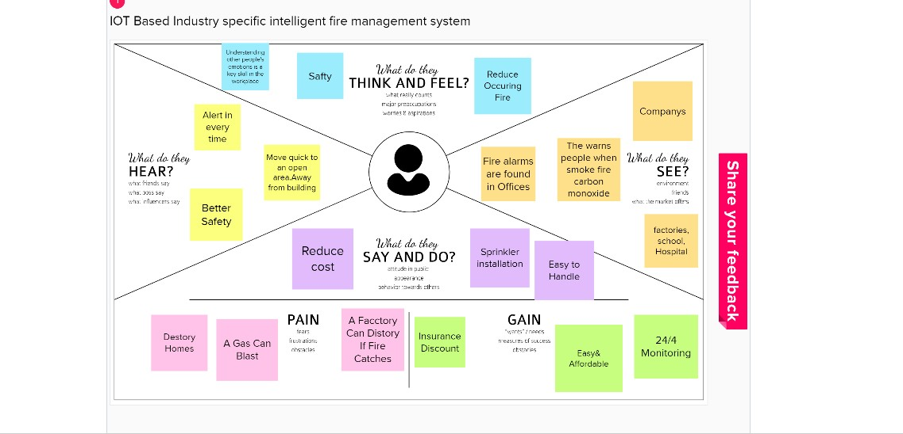

## Ideation & Brainstorming

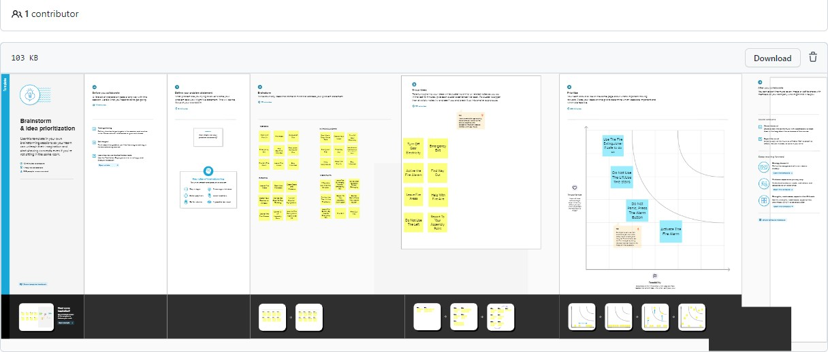

* 1. **Proposed Solution**

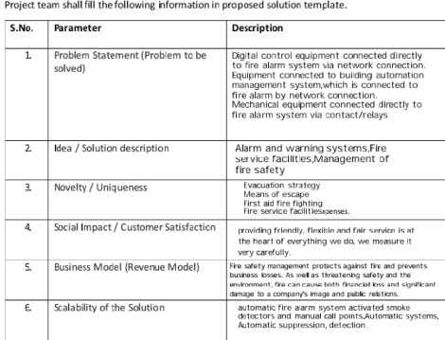

## Problem Solution fit

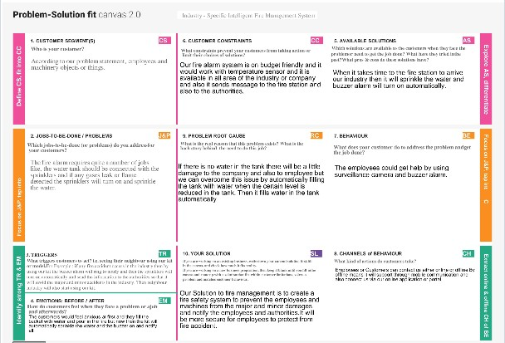

1. **REQUIREMENT ANALYSIS**

## 4.1 Functional requirement

|  |  |  |
| --- | --- | --- |
| **FR No.** | **Functional Requirement (Epic)** | **Sub Requirement (Story / Sub-Task)** |
| FR-1 | User Registration | Registration through e-mail id&Mobile Number |
| FR-2 | User Confirmation | Confirmation via Email Confirmation via OTP |
| FR-3 | Web Applications | Node Service |
| FR-4 | Configure to Device | IBM Wastson IoT Platform |
| FR-5 | Data base | Cloudant DB |
| FR-6 | Python Script | IBM IoT Platform |

**Non-functional Requirements:**

Following are the non-functional requirements of the proposed solution.

|  |  |  |
| --- | --- | --- |
| **FR No.** | **Non-Functional Requirement** | **Description** |
| NFR-1 | **Usability** | used to protect the damage from fire |
| NFR-2 | **Security** | Information about increase in changes in situation is secured |
| NFR-3 | **Reliability** | More Consistency and Dependability |
| NFR-4 | **Performance** | Easy to moniter and measure the Temperature |
| NFR-5 | **Availability** | Available IN defined Geofence |

|  |  |  |
| --- | --- | --- |
| NFR-6 | **Scalability** | To exceed future Demand |

## 5 PROJECT DESIGN

* 1. **Data Flow Diagrams**

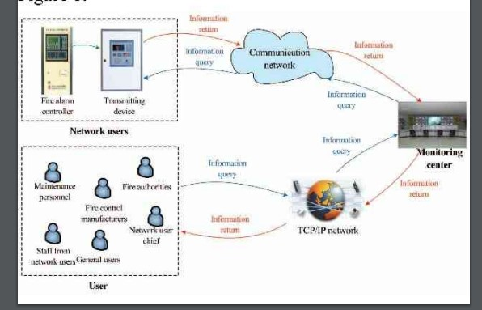

## Solution & Technical Architecture

Solution Architecture:

Solution architecture is a complex process – with many sub-processes – that bridges the gap between business problems and technology solutions. Its goals are to:

* Find the best tech solution to solve existing business problems.
* Describe the structure, characteristics, behavior, and other aspects of the software to project stakeholders.
* Define features, development phases, and solution requirements.
* Provide specifications according to which the solution is defined, managed, and

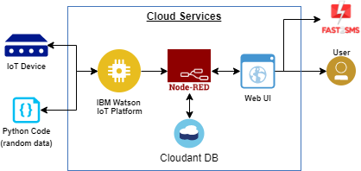delivered

## User Stories

**Table-1 : Components & Technologies:**

|  |  |  |  |
| --- | --- | --- | --- |
| **S.No** | **Component** | **Description** | **Technology** |
| **1** | **User Interface** | **How user interacts with**  **application e.g.**  **Web UI, Mobile App,**  **Chatbot etc.** | **HTML, CSS,**  **JavaScript / Angular Js / React**  **Js etc.** |
| **2** | **Application Logic-1** | **Logic for a process in**  **the application** | **Java / Python** |
| **3** | **Application Logic-2** | **Logic for a process in**  **the application** | **IBM Watson STT**  **service** |
| **4** | **Application Logic-3** | **Logic for a process in**  **the application** | **IBM Watson Assistant** |
| **5** | **Database** | **Data Type, Configurations etc.** | **MySQL, NoSQL,**  **etc.** |
| **6** | **Cloud Database** | **Database Service on**  **Cloud** | **IBM DB2, IBM**  **Cloudant etc.** |
| **7** | **File Storage** | **File storage requirements** | **IBM Block Storage or Other Storage Service or Local** |

|  |  |  |  |
| --- | --- | --- | --- |
|  |  |  | **Filesystem** |
| **8** | **External API-1** | **Purpose of External API used in the application** | **IBM Weather API,**  **etc.** |
| **9** | **External API-2** | **Purpose of External API used in the application** | **Aadhar API, etc.** |
| **1** | **Machine Learning**  **Model** | **Purpose of Machine Learning Model** | **Object Recognition**  **Model, etc.** |
| **1** | **Infrastructure (Server / Cloud)** | **Application Deployment on Local System / Cloud**  **Local Server Configuration:**  **Cloud Server Configuration :** | **Local, Cloud Foundry,**  **Kubernetes, etc.** |

## Table-2: Application Characteristics:

|  |  |  |  |
| --- | --- | --- | --- |
| **S.No** | **Characteristics** | **Description** | **Technology** |
| **1** | **Open-Source Frameworks** | **List the open-source frameworks used** | **Technology of Opensource framework** |
| **2** | **Security Implementations** | **List all the security / access controls implemented, use of**  **firewalls etc.** | **e.g. SHA-256, Encryptions, IAM Controls, OWASP**  **etc.** |
| **3** | **Scalable Architecture** | **Justify the scalability of architecture (3 – tier, Micro-services)** | **Technology used** |

|  |  |  |  |
| --- | --- | --- | --- |
| **4** | **Availability** | **Justify the availability of application (e.g. use of load balancers, distributed servers**  **etc.)** | **Fire Alarm,smoke**  **sensor** |
| **5** | **Performance** | **Design consideration for the performance of**  **the application (number of requests per sec, use of Cache, use of CDN’s) etc.** | **Monitor the fire& Monitor the Alarm** |

1. **PROJECT PLANNING & SCHEDULING**

## Sprint Planning & Estimation

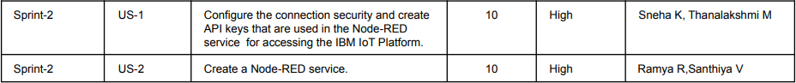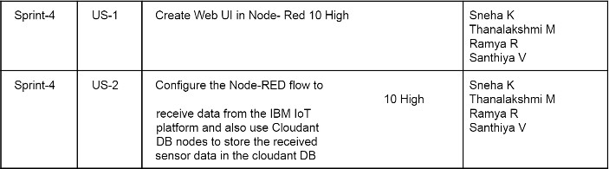

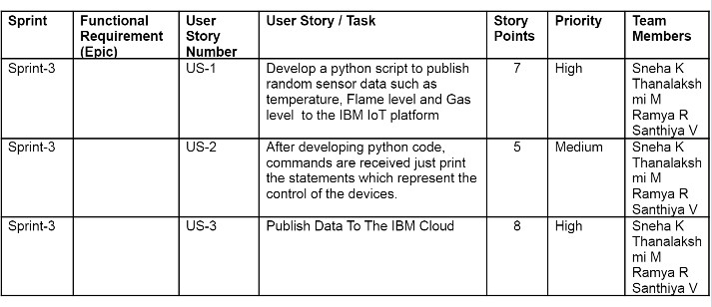

* 1. **Sprint Delivery Schedule**

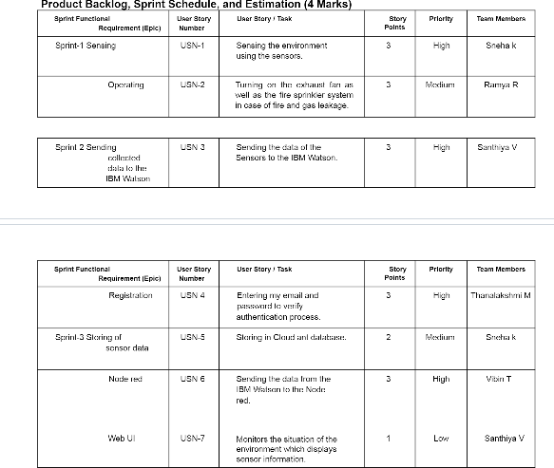

Project Tracker, Velocity & Burndown Chart: (4 Marks) Velocity:

Imagine we have a 10-day sprint duration, and the velocity of the team is 20 (points per sprint). Let’s calculate the team’s average velocity (AV) per iteration unit ( story points per day)



## Reports from JIRA

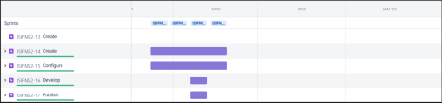

https://pnt2022tmid47460.atlassian.net/jira/software/projects/ISIFMS2/boards/2/roadmap

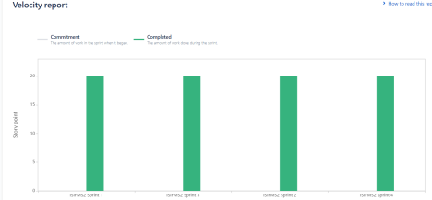

## CODING & SOLUTIONING

* 1. **Feature 1**

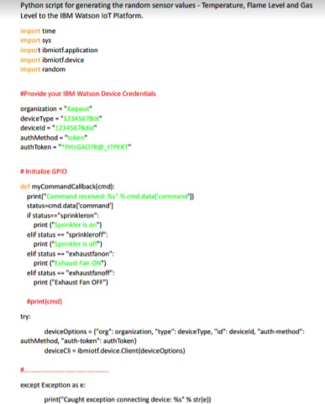

## Feature 2

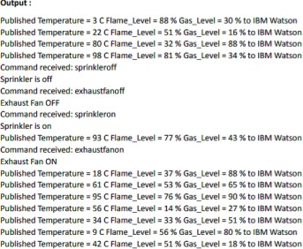

1. **TESTING**

## Test Cases

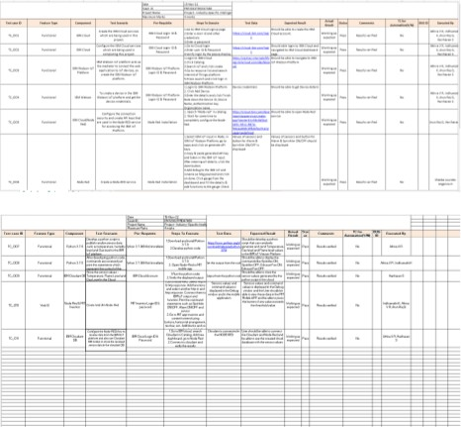

* 1. **User Acceptance Testing**

Purpose of Document : The purpose of this document is to briefly explain the test coverage and open issues of the Industry-specific intelligent fire management system project at the time of the release to User Acceptance Testing (UAT).

**Defect Analysis :**

**Pass** 7

**Section**

Print the Sensor values Client Mobile Application Security

51

2

This report shows the number of resolved or closed bugs at each severity level, and how they were resolved

|  |  |  |  |
| --- | --- | --- | --- |
| **Severity 1** | **Severity 2** | **Severity 3** | **Severity 4** |
| 10 | 4 | 2 | 3 |
| 1 | 0 | 3 | 0 |

|  |  |  |  |
| --- | --- | --- | --- |
| 2 | 3 | 0 | 1 |
| 11 | 2 | 4 | 20 |
| 0 | 0 | 1 | 0 |
| 0 | 0 | 1 | 1 |
| 0 | 0 | 0 | 1 |

**Resolution Subtotal** By Design 20 Duplicate 4 External 6 Fixed 37 Not Reproduced 1 Skipped

Totals 24 14 13 26 70 **Test Case Analysis**

2 Won't Fix 8

This report shows the number of test cases that have passed, failed, and untested

|  |  |  |
| --- | --- | --- |
| 3 | 0 | 0 |
| 9 | 0 | 0 |
| 4 | 0 | 0 |

Outsource Shipping 3 Exception Reporting 9 Final Report Output 4 Version Control 2 0 0 2

## RESULTS

* 1. **Performance Metrics**

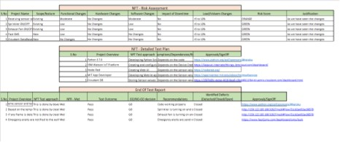

## ADVANTAGES & DISADVANTAGES

The Advantages of this Industry-Specific Intelligent Fire Managment system are as follows

* + - The user need not require expertise knowlege to control this system. This system

is simple. The user can easily view the sensor values and take control actions. **●** The control actions are taken automatically.

* + - If it is implemented in hardware, then the cost of implemention will be affordable. **●** As we are sensing the sensor values continously, any slight change in the environment is detected
    - This system is in User-Friendly format.

The Disadvantage of this Industry-Specific Intelligent Fire Managment system are as follows ● This system will not be able to detect the orgin of fire.

* This system will not provide the escape route if there is fire outbreak. ● If the

industry has specific changes in the environment, then this system will gives false alarm.

## CONCLUSION

An understanding and having Fire Managment system in the industry is of utmost importance.This project is a fire management system that can be user in the industry based on IOT.This system creates a simulation device cedentials in IBM WATSON IOT PLATFORM.In node red,necessary nodes are installed and used.These nodes are installed and used.These nodes are deployed and the data is collected.In the event of fire, this system can issue sprinkler on,exhaust fan on.This remote user monitoring system can monitor the system status of each node in real time.This system monitors the data continuously so that the any slight change in the environment can be easily detected.This ensures good control accracy .ThisIndustry-Specific Intelligent Fire Managment ensures the protection of property, asset and the processes are cost effective and the automatic measures are in control.

## FUTURE SCOPE

The future scope of this project is to add additonal featureslike triggering the extinguisher automatically, predict the escape route if the fire outbreaks and to implement this system in real time using hardware**.**

## 13.APPENDIX

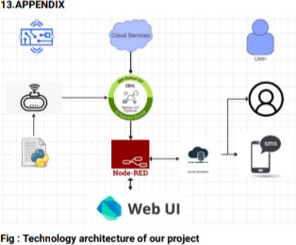

Source Code

https://github.com/IBM-EPBL/IBM-Project-5300- 1658756270/tree/main/Develop%20a%20Python%20 Script

GitHub & Project Demo Link

<https://drive.google.com/file/d/1Ru4EM634BgbdLOEMuLyfZ0fDVz9RKpr2/view?usp=drivesdk>